Resources for gathering information during Fire:


PulsePoint App The first alert that there may be a fire comes from this app. Every call that San Benito Fire gets called to is logged here. Sign up to follow Hollister Fire CA. You can sign up for the alerts you want such as confirmed fire; vegetation fire; car accident, etc. It has an auditory and visual notification. The app will also let you know which emergency agencies and vehicles have responded. From Wikipedia: The app's main feature, and where its name comes from, is that it sends alerts to users at the same time that dispatchers are sending the call to emergency crews.[3] The goal is to increase the possibility that a victim in cardiac arrest will receive cardiopulmonary resuscitation (CPR) quickly. The app uses the current location of a user and will alert them if someone in their vicinity is in need of CPR.

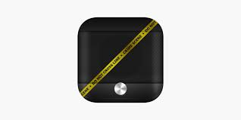
911 Dispatch App Once you know of an incident, to learn more, click on 911 Dispatch to hear scanner traffic. Choose your state, first then there will be a long list of scanners that you can listen to. The list has grown, lately but for this area BEU San Benito Public Safety has been useful. Other potential channels to listen to include Monterey Sheriff; Cal Fire BEU; and Monterey County Fire Agencies. The list is long and takes some time to find the appropriate scanner so its good to familiarize yourself during a nonemergency. You can go to each scanner of interest, open it up and use the send symbol in top right hand corner to add to your favorites list for easy access.


Flightradar24 App This is a great source for tracking the Cal Fire/ US Forest Service planes. Click on the app, use your fingers (touch screen) to move the map to your area. A blue dot should show your location within that area. If in San Juan Canyon, the Hollister airport is just NE and is where CAL FIRE air support is based. You will see planes flying on this map in real time. Click on one with your finger and it will provide more information on the plane (ETA; type of plane, etc.) as well as tracking. To switch to a different plane, simply put your finger on a different plane. In San Juan Canyon, we often see and hear the fire planes en route to the Monterey Peninsula. Clicking on the plane in the app gives you a good idea, early, if its something we need to worry about in our area. It also gives you a good sense on a big fire, where the hot spots are; which way the fire is moving and which air support resources are working the fire. Play around with it. This is a really interesting app.


Watch Duty app Also has a desktop component, https://www.watchduty.org/ This is a brand new app which has been used in Northern California counties before just recently become available to the entire state of California (as of June 1, 2022). Its an early alert system for wildfire. Many of the Twitter accounts that provide information on fire, are the sources and reporters for this app. In the short time it has been around, it has provided timely, good information on local fires in San Benito and Monterey Counties. As it gains traction, it will only get better. This is both crowd sourced information and reporter. Crowd sourced information is vetted before publishing. This is and will be a must have app for anyone living in the WUI of California. It has a visual and auditory notification system.

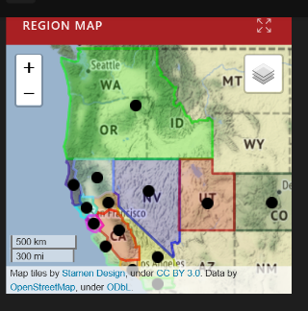
https://alertca.live/ This is a system of wildfire web cams available to the public however, only Cal Fire has the ability to move the cameras around. Click on the area from the map you want to access. There are multiple cameras in the tri-county area but the most useful for our area is the Fremont Peak cam. This is a system that has only been in place for a few years but has been so useful and successful that more cameras are being added all the time. For now, it is in the Western States of WA, OR, CA, NV, UT and CO but will almost certainly move into other fire prone states such as AZ and NM. This is another good website to play around with before you need it. It is also fun for catching sunsets, or seeing if the fog is in. It has been very useful for catching wildfires, early and providing residents and first responders with real time visuals.

CHP Traffic Incident Information Page
https://cad.chp.ca.gov/Traffic.aspx This website provides a transcript of scanner information. Click on Monterey as the communication center (for this area) and a list of current incidents will come up. If there is an incident named Report of Fire, you can click on the Details button on the far left of that line and a transcribed scanner log comes up. Scanner information is abbreviated and uses codes known by first responders. This is another website that will have a little bit of a learning curve. But, provides real time information on current events.

***If you learn of an incident that may affect the canyon, please let others know whether it’s a text to a neighbor or posting in Nextdoor. On Nextdoor, posting as a safety or urgent post to the canyon is the only way to ensure neighbors are alerted, quickly. That said, Nextdoor hasn’t been very reliable but good for broadcasting information, as a backup.. But, the main message is let someone know so word gets out. Some residents may take longer to prepare for evacuation than others. Also, if you see or smell fire in or near the canyon that you aren’t seeing on Pulsepoint, CALL 911 and also, at least a neighbor or two. We are all in this together and the more each of us learns about how to source fire information, the safer all of us will be.

